IT3037C
Lab#04: AWS S3 Lab

In this lab, you will study Amazon S3 object storage. You will use the AWS CLI commands to create an S3 buckets. Also, you will also learn to deploy static websites through S3.

Tools and Materials

- Amazon AWS security credentials.
- AWS CLI
- Ubuntu Command Line

Here's a step-by-step guide to creating an S3 bucket, uploading a file, and making the bucket public using the AWS CLI:
Prerequisites:
- AWS CLI installed
- AWS credentials configured (aws configure)

1. Create an S3 Bucket
aws s3api create-bucket --bucket your-bucket-name --region us-east-1
Replace your-bucket-name with your desired bucket name. If you're using a region other than us-east-1, replace that as well.

What did you see?
{
"Location": "/hazletsl"
}
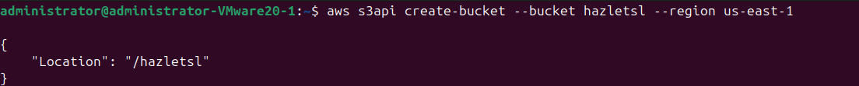

Verify that your bucket exist with the following command:
aws s3 ls
What did you see?
2025-10-12 13:43:16 hazletsl
2. Create & Upload a File to the Bucket
vi testfile.json

Paste the following:
This is my IT3037 website! It Works!

aws s3 cp /path/to/your/testfile.json s3://your-bucket-name/
Replace /path/to/your/file.txt with the path to your file and your-bucket-name with your actual bucket name.
What did you see?
upload: ./testfile.json to s3://hazletsl/testfile.json
3. Make the Bucket Publicly Readable
S3 buckets by default are private. To make the bucket and its contents public, apply a bucket policy.
Step 3.1: Create a JSON policy file (bucket-policy.json) with the following content:
{
"Version": "2012-10-17",
"Statement": [
{
"Sid": "PublicReadGetObject",
"Effect": "Allow",
"Principal": "*",
"Action": "s3:GetObject",
"Resource": "arn:aws:s3:::your-bucket-name/*"
}
]
}
Replace your-bucket-name with your actual bucket name.
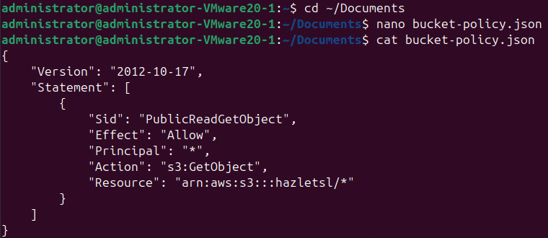
Next you will need to check the permission of your bucket to do so enter the following command:
aws s3api get-public-access-block --bucket your_bucket_name
What did you see?
{
"PublicAccessBlockConfiguration": {
"BlockPublicAcls": true,
"IgnorePublicAcls": true,
"BlockPublicPolicy": true,
"RestrictPublicBuckets": true
}
}
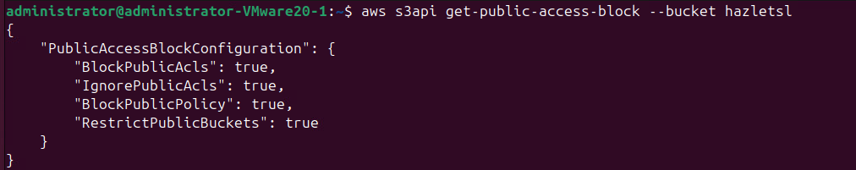
You will need to delete your bucket policy first to allow public access:
aws s3api delete-public-access-block --bucket your_bucket_name
aws s3api put-bucket-policy --bucket hazletsl --policy file:///home/administrator/Documents/bucket-policy.json
Then enter:
aws s3api put-bucket-policy --bucket your-bucket-name --policy file://bucket-policy.json
What did you see?
Then verify your new bucket policy aws s3api get-bucket-policy --bucket <bucket-name>
What command did you run? What did you see?
aws s3api get-bucket-policy --bucket hazletsl
{
"Policy": "{\"Version\":\"2012-10-17\",\"Statement\":[{\"Sid\":\"PublicReadGetObject\",\"Effect\":\"Allow\",\"Principal\":\"*\",\"Action\":\"s3:GetObject\",\"Resource\":\"arn:aws:s3:::hazletsl/*\"}]}"
}
4. Verify the File is Public
Once the policy is applied, you can verify that the file is public by accessing the file URL in your browser:
https://your-bucket-name.s3.amazonaws.com/testfile.json

What did you see? Is your webpage available?
This is my IT3037 website! It Works!
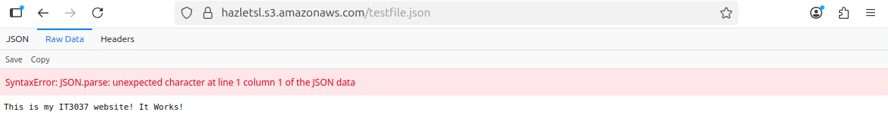

Clean-Up

1. Empty the Bucket
Before deleting a bucket, you need to remove all its objects. You can use the aws s3 rm command with the --recursive option to delete all objects from the bucket.
aws s3 rm s3://your-bucket-name --recursive
This command will delete all the objects and folders in the bucket.
What did you see?
delete: s3://hazletsl/testfile.json
2. Delete the Bucket
Once the bucket is empty, you can delete the bucket itself:
aws s3api delete-bucket --bucket your-bucket-name --region your-region
Replace your-region with the region where your bucket is hosted (e.g., us-east-1).
What did you see?
Confirm by typing “ aws s3 ls “

What did you see?
This should return no bucket names
Submission instruction

After completing this work, submit this word document with your answers to the Canvas. In your word document, your answers should be in blue font.

